CSS
CSS : Cascading style sheet

We can apply CSS to a page using 3 methods

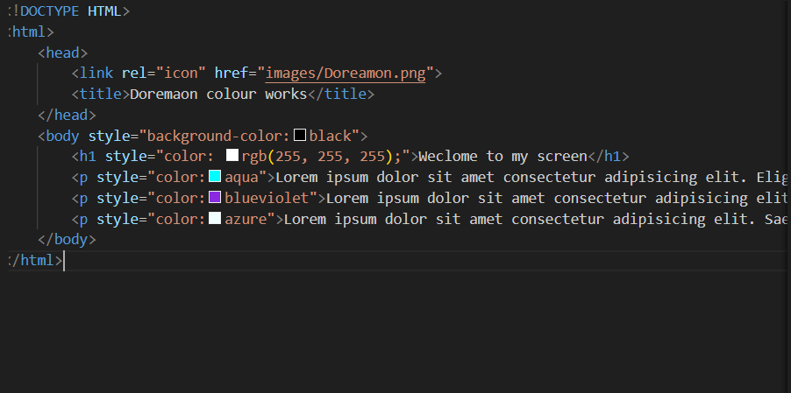
1.INLINE Styling

This is know an inline method , where you can apply colours internally

2.INTERNAL Styling:
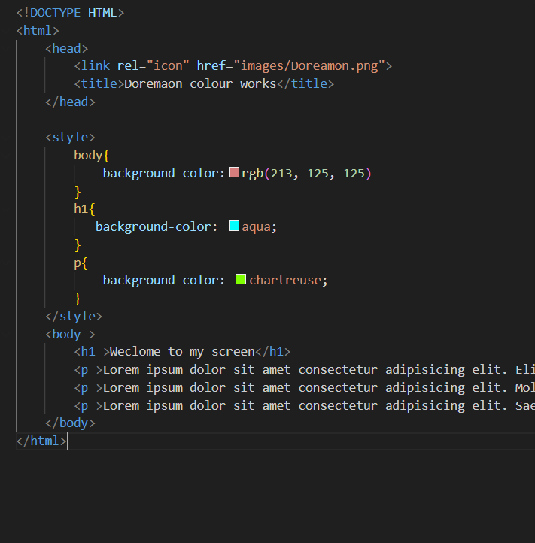

3.EXTERNAL Styling:

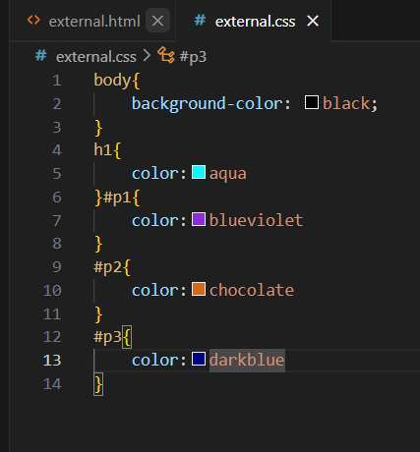
Here you will generally link your Non styled simple HTML file to a css file which has all the decorations for this HTML file
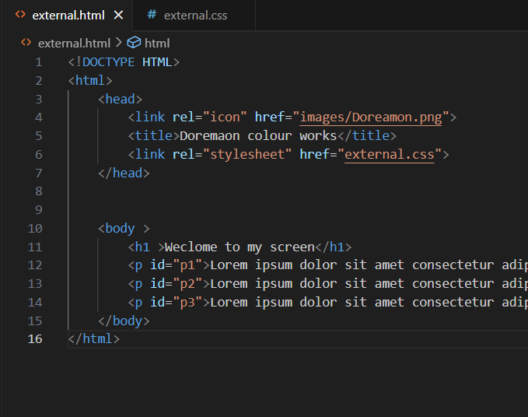

if you want to add colours individually to individual para , we need to add some random ID to separate them

and we can also seperate using classes
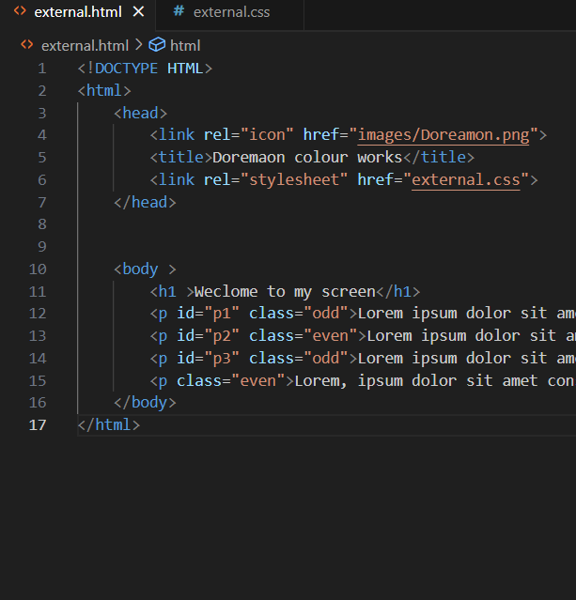
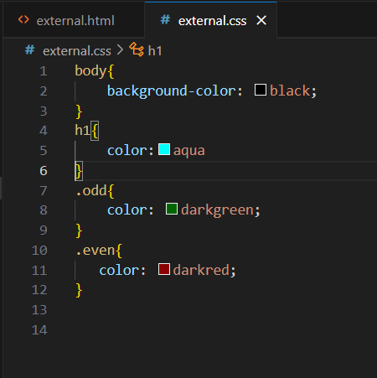

Borders:
<style>
h1{
border-style:solid ;
border-width: 5px;
border-color: rgb(248, 8, 12);
border-radius:20px;
}
#p1{
border-style:dotted;
border-width: 5px;
border-top-width: 5px;
}
</style>

You can just explore borders as there are lot of Variations in that...,These above things are just for basic Syntax

NOTE: Here in all cases i am using internal styling only , inorder to make it clear and simple but the effective styling while we are working in realtime projects is external styling...

SHADOWS:
<style>
h1{
text-shadow: 7px 4px 10px red,1px 1px 5px blueviolet;
border-style: solid;
border-radius: 100px;
}
p{
text-shadow: 7px 4px 6px rgb(179, 0, 255);
}

</style>

text-shadow:( horizontal )px (vertical)px (shadow)px color

The above one is General form of syntax for creating shadows using CSS

MARGINS
Margins is a wonderful and very useful topic in CSS

<style>
body{
margin:0px

}

.box{
border: 5px solid;
width: 350px;
height:150px;
font-size: 75px;

}
#b1{
background-color: brown;
margin:auto;
}
#b2{
background-color: darkgray;
margin:auto;
}
</style>

margins are nothing but spaces around the text ,,,margin==space

